**Popularization and development of compulsory education in New China**

**________________________________________**

**A Research Proposal Submitted to**

**Dr. Arthur S. Abulencia, Faculty of Graduate School**

**Jose Rizal University**

**Mandaluyong City**

**________________________________________**

**In Partial Fulfillment of the Requirements for**

**GS 222 Research Methods**

**________________________________________**

by

**Avine**

**September 2020**

**Statement of the Problem**

  How is new China in nearly 70 years universal compulsory education?

After the completion of compulsory education popularization, the development to now have those great changes?

**Significance of the Study**

As a graduate student of pedagogy, I should have a comprehensive understanding of the development course of modern compulsory education in China and provide guidance for the future education work

**Setting and Target Respondents**

* Where are you going to conduct your research? Place of research: it maybe school, or city or district or province?

Online search , and China

* Who are the respondents or participants in your research?

The teacher who is a middle school teacher.

* How are you going to select your participants or respondents?

Asking online by wechat .

**Scope and Limitations of the Study**

* What are the limits or your research?

Time limits : New China begging 1949 - now

Object limits ：compulsory education

**Chapter 1 INTRODUCTION**

**Abstract:**  At the beginning of the founding of new China, talent shortage, lack of educational resources, at that time school-age children primary school enrollment rate of less than 20%, junior high school enrollment rate of only 6%, more than 80% of the population is illiterate. Since the founding of the People's Republic of China, the development of compulsory education has made remarkable historical achievements. After 70 years of development, the basic education has made remarkable achievements: 46,564,200 children in kindergartens and 4.531 million kindergarten teachers and staff; In the basic education stage, there were 504,800 schools, with 235,910,900 students and 2,581,400 full-time teachers. It has made a major contribution to the modernization drive.

**Chapter 2 Review of Related Literature and Studies**

**I. The beginning and development of the popularization of compulsory education before the reform and opening up**

(I) Popularization of primary compulsory education in the early years of the People's Republic of China (1949-1957)  
 After the founding of new China, the government put universal education in the strategic position of "top priority" in education construction. The Common Program, which was adopted on the eve of the founding of the People's Republic of China and played the role of interim constitution at the beginning of the founding of the People's Republic, clearly states: "Universal education should be carried out in a planned and step-by-step way... To meet the broad needs of national construction." The first National Conference on Primary Education and the first National Conference on Normal Education, held from August to September 1951, also put forward that "within ten years, we will try to enroll almost all school-age children, and within five years, we will try to enroll 80 percent of school-age children.

(2) The Tortuous Development of the popularization of primary education during the Period of "Great Leap Forward" and "Adjustment" (1958-1965)  
In 1958, the number of primary schools nationwide reached 776,800, an increase of 229,500 or 41.93 percent over 1957. In that year, the number of primary school students nationwide was 6.403 million, an increase of 22.12 million or 34.41 percent over 1957. In 1958, the average enrollment rate of school-age children nationwide reached 80.3 percent, an increase of 18.6 percent over 1957.

(3)The obstruction and delay of universal education during the cultural Revolution (1966-1976)  
During the "Cultural Revolution", education suffered unprecedented destruction, and education was in chaos. In the field of basic education, in the early period of the "Cultural Revolution", under the influence of the extreme "left" ideological trend, the achievements of education construction in the 17 years since the founding of the People's Republic were completely denied. In narrow education serve for the proletariat political (as well as to serve the class struggle) policy around, around the so-called dare to rush, to dare to do, buck the trend, outstanding proletarian political theme, on the foundation education the most destructive since the founding of the so-called "revolution", length of schooling is wanton shorten, the teaching content is wanton streamline, teachers' personal dignity by trample, in basic education quality have fallen to their lowest level since the founding of the people. It is difficult to maintain the normal running order of basic education, especially the popularization of education.

**II. The popularization and development of compulsory education since the reform and opening up**

(I) Restoration and Preliminary Development of Universal Education (1977-1985)  
After the end of the "Cultural Revolution", universal primary education was officially put on the agenda along with the efforts to put things right. From October 1978 to January 1979, the Ministry of Education successively issued the Notice on Inspecting and Popularizing the five-year Education in Rural Primary Schools and the Notice on Continuing to Earnestly do a good job in popularizing the five-year Education in rural primary schools, making instructions on the work of popularizing the five-year education in rural primary schools.

(2). Comprehensive Promotion of universal Compulsory Education (1986-2000)  
1. Full implementation of Compulsory Education (1986-1992)  
In April 1986, the Compulsory Education Law of the People's Republic of China was promulgated. The law provides in principle some important issues such as the nature, duration and guarantee of compulsory education, which indicates that the popularization and development of compulsory education in China has entered a new stage of legalization.

2. Continuous Promotion of Compulsory Education (1993-2000)  
In February 1993, the State Council issued the Outline for China's Educational Reform and Development, which clearly set the goal of making nine-year compulsory education basically universal and basically eliminating illiteracy among young and middle-aged adults by the 1990s. After July 1994, the State Council, the state education commission has issued "on the implementation of the" Chinese education reform and development compendium > opinions on the basic popularization of nine-year compulsory education in the 90 s and basically eliminating illiteracy among young and middle-aged adults of the implementation opinions "and other documents, to the specific requirements, objectives, steps and implementation methods, evaluation of acceptance make that clear. In March 1995, the National People's Congress passed the Education Law of the People's Republic of China. Article 18 and Article 57 of the Law clarified the rights, obligations and sources of funds of compulsory education, thus forming the legal system of compulsory education in China.  
In order to ensure the achievement of the goal of popularizing the nine-year compulsory education law, under the joint organization of the Ministry of Education and the Ministry of Finance, the central government allocated 3.9 billion yuan for this period and 8.7 billion yuan for local matching funds. The first phase of the National Project for Compulsory Education in Poverty-stricken Areas (1995-2000) was carried out, which greatly improved the conditions for running schools in compulsory education, especially in poverty-stricken areas.

(3)**Rapid development of compulsory education since the new century (2001-)**

1. We will promote the strategic plan for popularizing compulsory education in poor rural areas  
In order to accelerate the popularization and development of compulsory education in rural areas and the poor areas in the central and western regions, and to develop compulsory education in urban and rural areas in a balanced way, and to create a gap in educational development, the State Council invested 5 billion yuan from the central government (with an additional 2.25 billion yuan from local governments as supporting funds) to implement the second phase of the National Compulsory Education Project for Poor Areas.

1. We will improve the management system for compulsory education in rural areas  
   In 1994 caused by "system" after the reform of rural compulsory education funding shortage, in May 2001, the State Council issued a "decision on reform and development of basic education, emphasis on rural compulsory education" under the leadership of the State Council, shall be the responsibility of the local government, system of classification management, mainly on county "(hereinafter referred to as" mainly on county "), the compulsory education of the school responsibility and administrative privileges on the county level, the compulsory education also changes from farmers for the main responsibility of the government.
2. Revise and promulgate the new Compulsory Education Law  
   In order to standardize the development of compulsory education by law, the Ministry of Education started the revision of compulsory Education Law at the end of 2003. After nearly three years of efforts, in June 2006 the newly revised compulsory education law article from 18 expansion in 1986 to 63, the schools, teachers, students, teaching, funds safeguard, and legal responsibility to do a comprehensive, clear will be fully incorporated into the scope of financial security, compulsory education "mainly on county" of the management system of compulsory education written law, compulsory education and the implementation of quality education to the law.
3. We will increase government funding for and investment in compulsory education, and make it free of charge across the board Service education is to realize the popularization of compulsory education with high quality. In the past ten years, our country has been strengthening the improvement and construction of the mechanism in the fund guarantee of compulsory education. According to the Ministry of Education, 4613.5 billion yuan was spent on education nationwide in 2018. Of this, the total investment in basic education reached 2925.1 billion yuan, including 367.2 billion yuan for preschool education, 2,085.8 billion yuan for compulsory education and 472.1 billion yuan for regular senior high schools.

Total input of national education

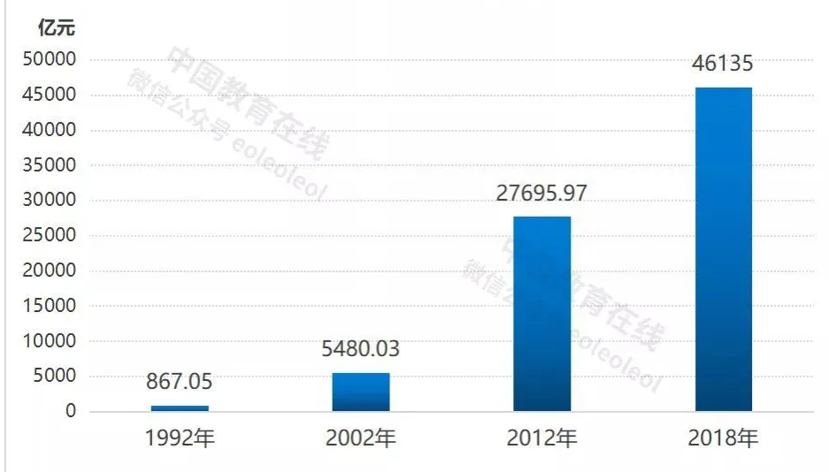

Source: Ministry of Education website

**III. Brilliant achievements have been made in basic education**

1. In April 2017, with the approval of the State Council, the Ministry of Education, the National Development and Reform Commission, the Ministry of Finance, and the Ministry of Human Resources and Social Security issued the Plan for The Popularization of High School Education (2017-2020). According to the plan, high school education will be universal nationwide by 2020, and the gross enrollment rate of all provinces (autonomous regions and municipalities directly under the Central Government) should reach more than 90 percent.

Compulsory education and high school gross enrollment rate

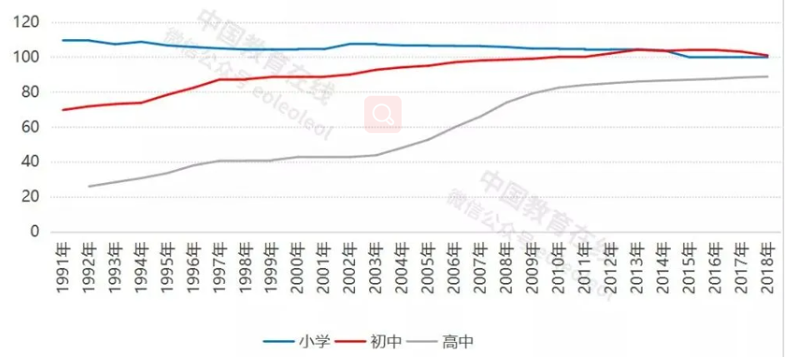

Source: Ministry of Education website 小学 ：primary school 初中：junior high school 高中：senior high school

1. **Pay attention to the construction of rural teachers, improve the treatment of teachers**

Popularity and improve the quality of compulsory education is the key to theimprovement of rural teachers' quality, to that end, countries attached great importance to the construction of rural teachers, such as the national implementation of rural compulsory education stage since 2006 school teachers (hereinafter referred to as post plan) AD hoc jobs plan, through public recruiting college graduates to "two basics" in western counties under the county rural compulsory education stage schools, guide and encourage college graduates to work in the rural education, step by step to solve such problems as insufficient total amount and the unreasonable structure of rural teachers, improve the overall quality of the contingent of rural teachers.  
With the rapid expansion of enrollment and enrollment of students at all levels, the number of full-time teachers at all levels of education also grows rapidly. Among them, the number of full-time primary school teachers increased from 836,000 to 6,091,900, an increase of 7.3 times. The number of full-time teachers in junior middle schools increased from 52,600 to 3.639 million, an increase of 69.2 times. The number of full-time teachers in regular high schools increased from 14,000 to 1,812,600, an increase of 129.5 times.

Comparison of the number of teachers at all levels in 1949 and 2018

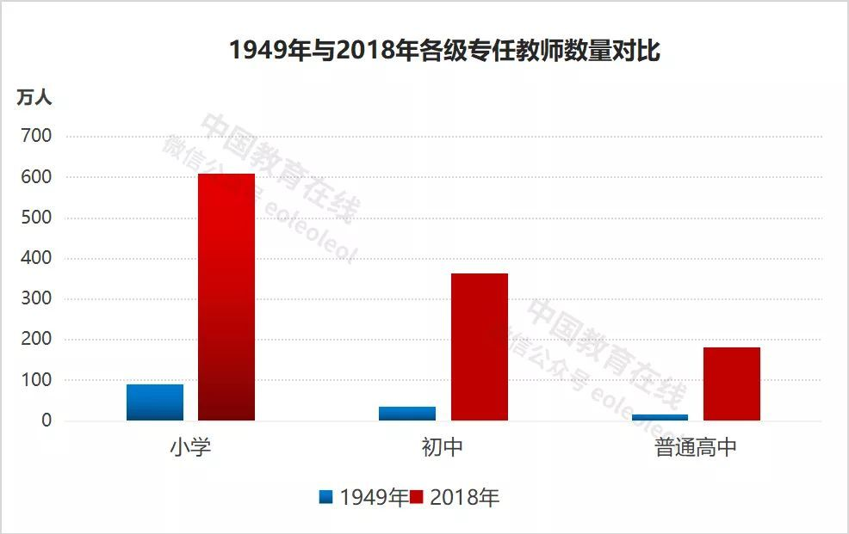

Source: Ministry of Education website 小学 ：primary school 初中：junior high school 普通高中：senior high school

1. The number of compulsory education and general high schools has been expanding

With the growth of the number of students at all levels of basic education in China, the number of schools at all stages of education is also increasing (except the primary stage). By 2018, China had 161,800 primary schools, 52,000 junior middle schools and 13,700 ordinary senior high schools.

Comparison of 2018 and 1949 schools at all levels

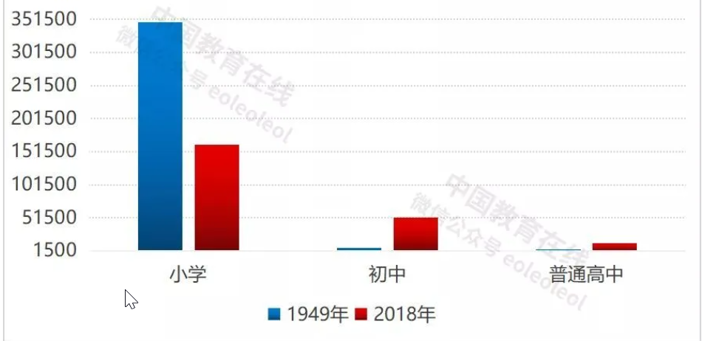

Source: Ministry of Education website 小学 ：primary school 初中：junior high school 普通高中：senior high school

4. The expenditure of education fund in the public finance budget continues to increase at all stages. In 2018, it was 12,733 yuan for regular primary schools nationwide; The national average junior high school is 18,481 yuan; The national average high school is 20,441 yuan.

Students at all stages of the public financial budget education expenditure

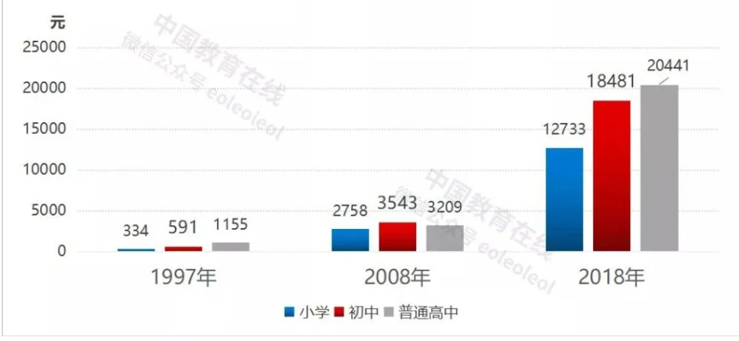

Source: Ministry of Education website 小学 ：primary school 初中：junior high school 普通高中：senior high school

**References**

* <https://gdae.gdedu.gov.cn/gdjyyjy/byyjcg/202008/f705b3813de547fab23e4880648019dd.shtml>
* <https://new.qq.com/omn/20191003/20191003A03JOW00.html>
* <http://www.moe.gov.cn/jyb_xwfb/s5147/201909/t20190926_401046.html>
* <https://www.theworldcouncil.net/uploads/8/6/2/1/86214440/wang_gce_vol._1_no._1_chinese.pdf>
* <http://www.hprc.org.cn/gsyj/whs/jys/201702/P020170223548371463677.pdf>
* <http://www.shxyj.org/Admin/UploadFile/20130926008/2015-09-07/Issue/tye11fkn.pdf>